Image: Rursus, WikiCommons, CC BY SA 3.0: <https://en.wikipedia.org/wiki/Julio-Claudian_dynasty#/media/File:JulioClaudian.svg>

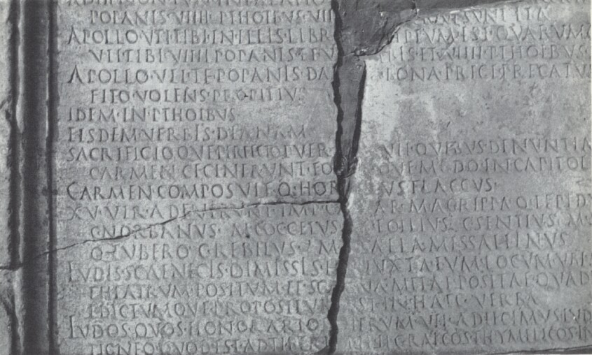

Figure 2.Two fragments of the Acta ludorum saecularium. Image: Public Domain <http://impero12.rssing.com/chan-9156852/all_p18.html#item343>

Figure 3. Pie chart illustrating the number of Julio-Claudian Quindecemviri who had held consulships. Image: Ewan Coopey.

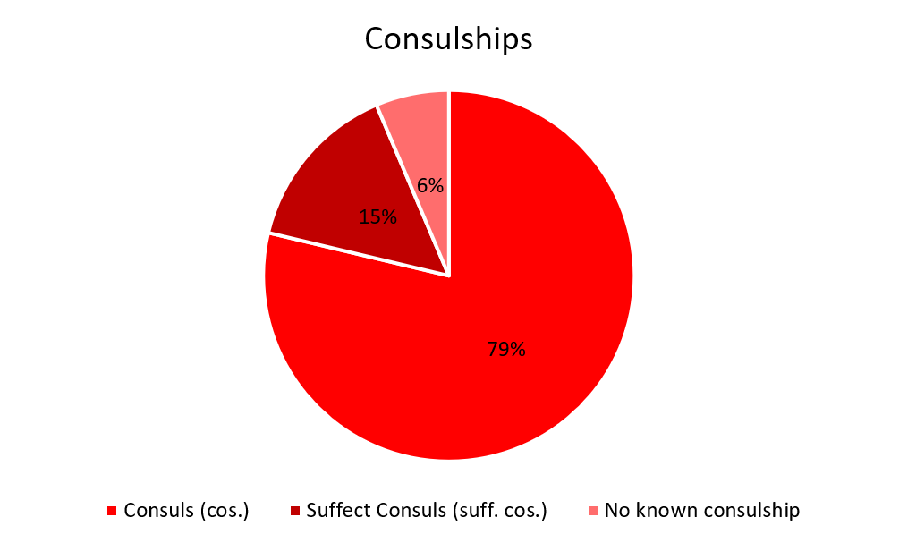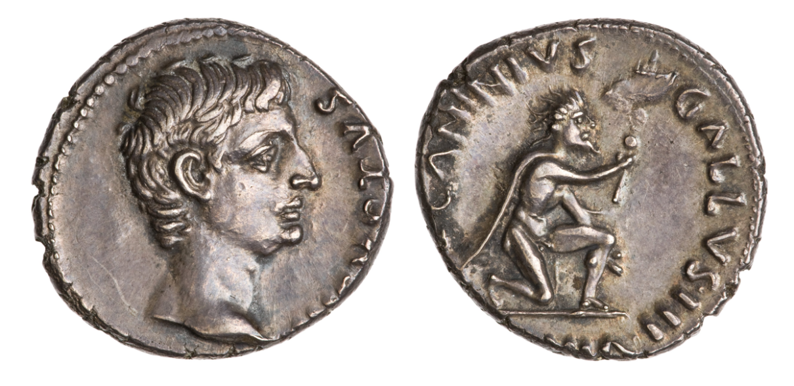

Figure 4. Obverse and reverse of RIC I2 416 Minted by Lucius Caninius Gallus in ? His name can be seen on the reverse: ‘CANINIUS GALLUS’. Image: American Numismatic Society, 1937.158.396, Public Domain. <http://numismatics.org/collection/1937.158.396>

Figure 6. IRT 273. Inscription upon temple of Augustan Gods in Leptis Magna, Africa. Image: joepyrek, WikiCommons CC BY SA 2.0: <https://commons.wikimedia.org/wiki/File:Leptis_Magna_(72)_(8288881469).jpg>

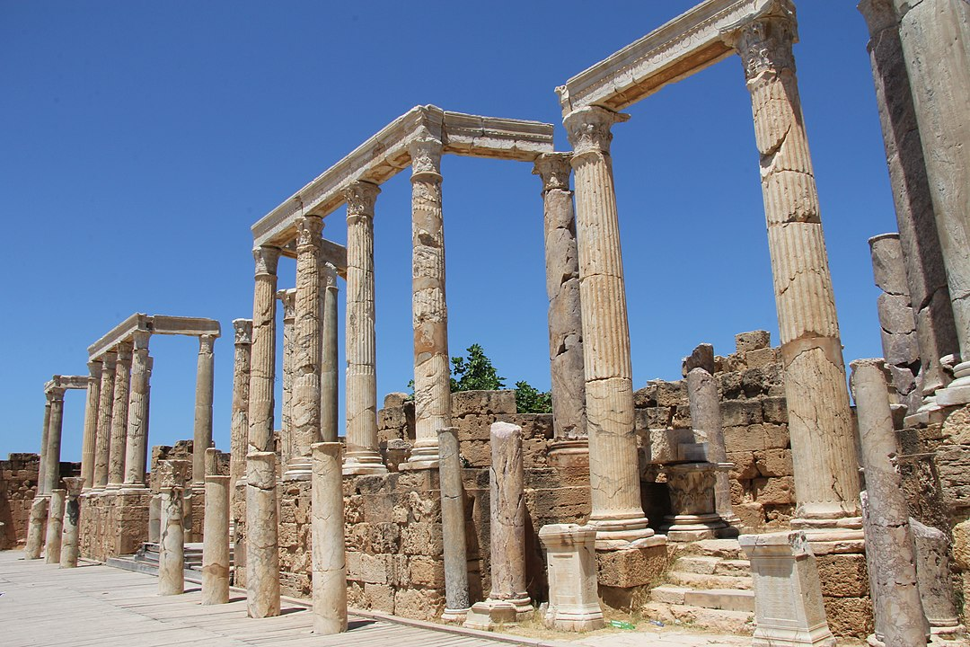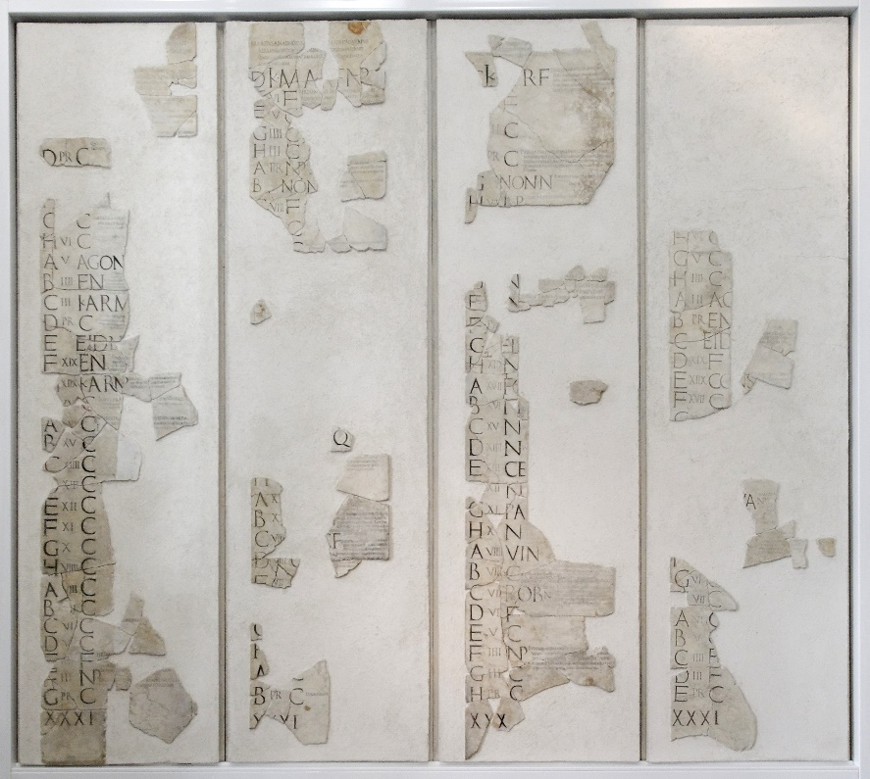

*Figure 5. Fasti Praenestini Massimo. Image: Jastrow, WikiCommons CC BY SA 2.5:* [*https://commons.wikimedia.org/wiki/File:Fasti_Praenestini_Massimo_n1.jpg*](https://commons.wikimedia.org/wiki/File:Fasti_Praenestini_Massimo_n1.jpg)